Name: PRATIK SUNIL ABHANG
Registration ID: 260640160209

Question 1

Question
Basic file permissions using symbolic mode
Create a file named project.txt. Configure its permissions so that:
• Owner can read and write
• Group can read only
• Others have no permissions
Verify the permissions after making the change.

Program
touch project.txt
chmod u=rw,g=r,o= project.txt
ls -l project.txt

Commands
touch project.txt
chmod u=rw,g=r,o= project.txt
ls -l project.txt

Input and Output
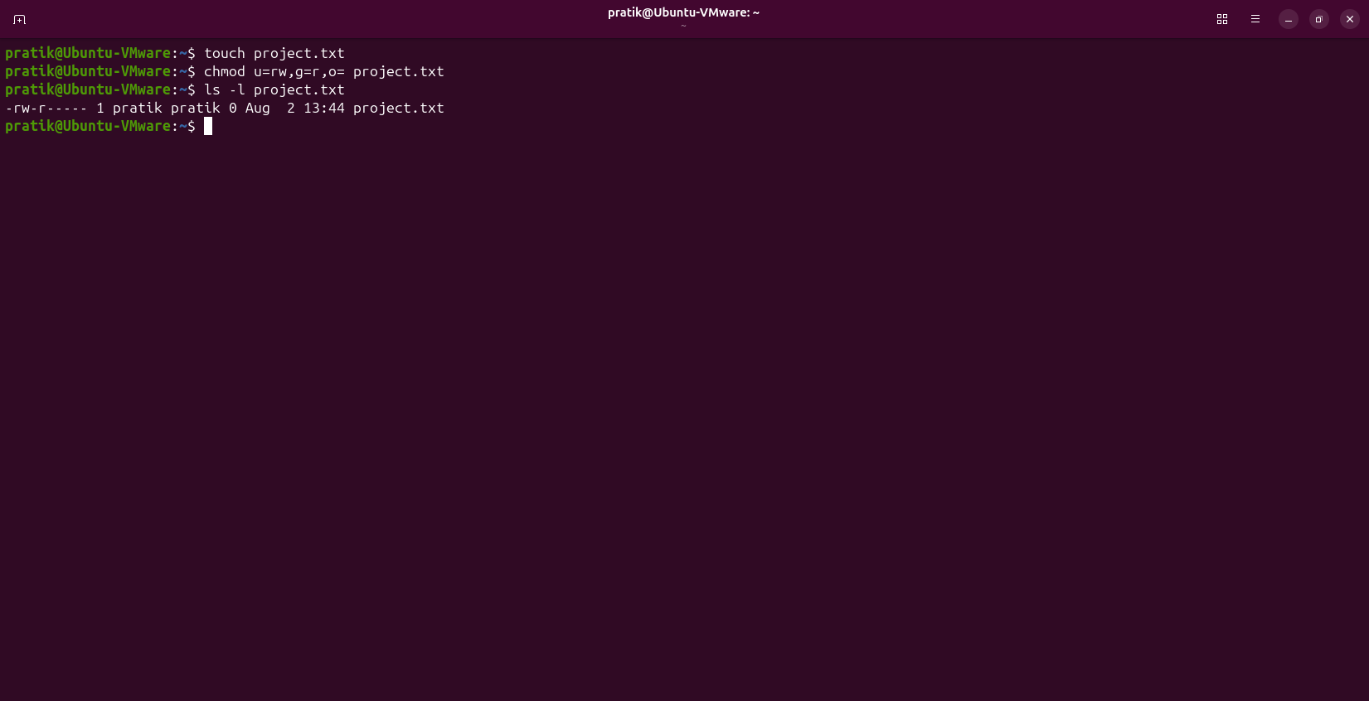

Question 2

Question
File permissions using numeric/octal mode
Create a file named script.sh. Using a numeric permission value, configure it so that:
• Owner has read, write, and execute
• Group has read and execute
• Others have read only
Verify the permissions using ls -l.

Program
touch script.sh
chmod 754 script.sh
ls -l script.sh

Commands
touch script.sh
chmod 754 script.sh
ls -l script.sh

Input and Output
